# Supplementary Materials

 **Supplementary Fig. 1.** Repeated-measures ANOVA results for three behavioral metrics (reaction time, accuracy, d-prime) across four visual stimulus categories (Body, Face, Place, Tool) and two memory load conditions (0-back vs. 2-back). (a) Stimulus category × load interaction effects; (b) Main effects of stimulus categories under differential memory load conditions (2-back - 0-back). Multiple comparisons corrected via FDR at q < 0.05.

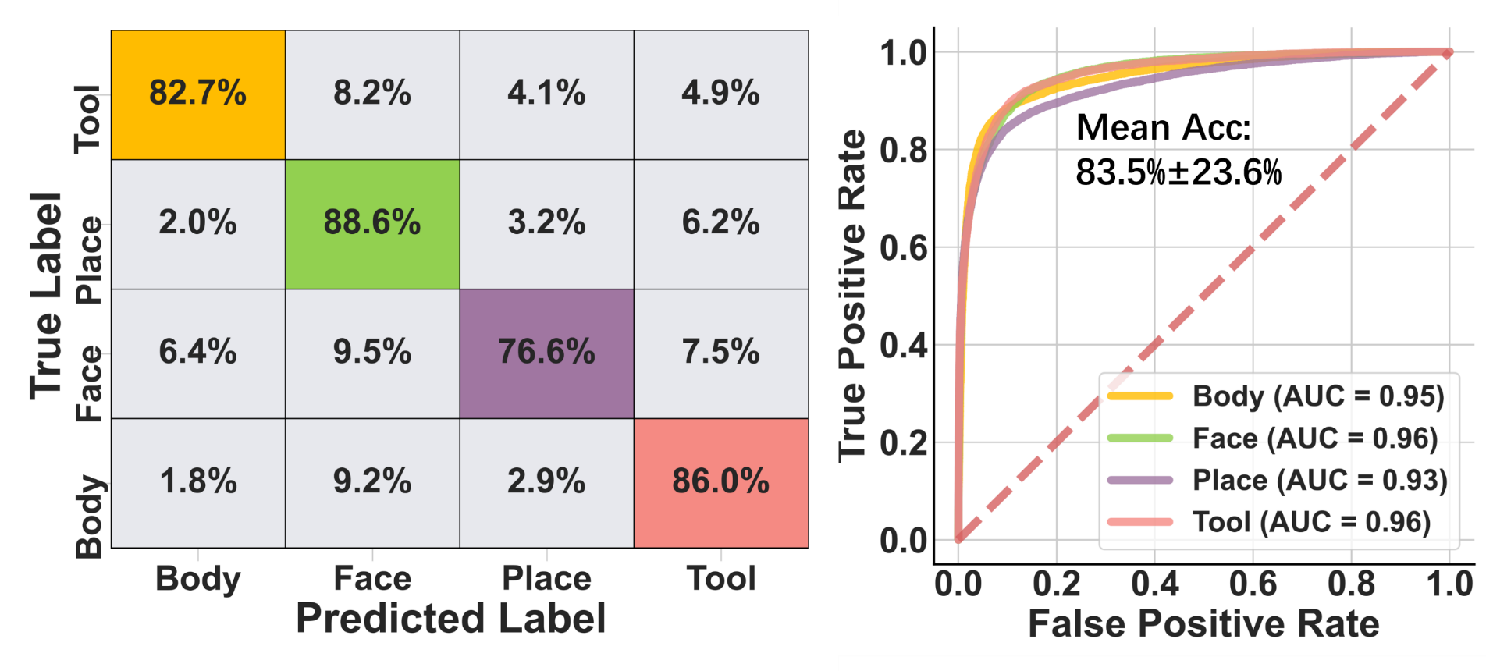

**Supplementary Fig. 2.** Classification performance on the trial-wise training dataset using RBF kernel SVM. Left: Confusion matrix for four-class categorization; Right: Receiver Operating Characteristic (ROC) curves of four-class classification。

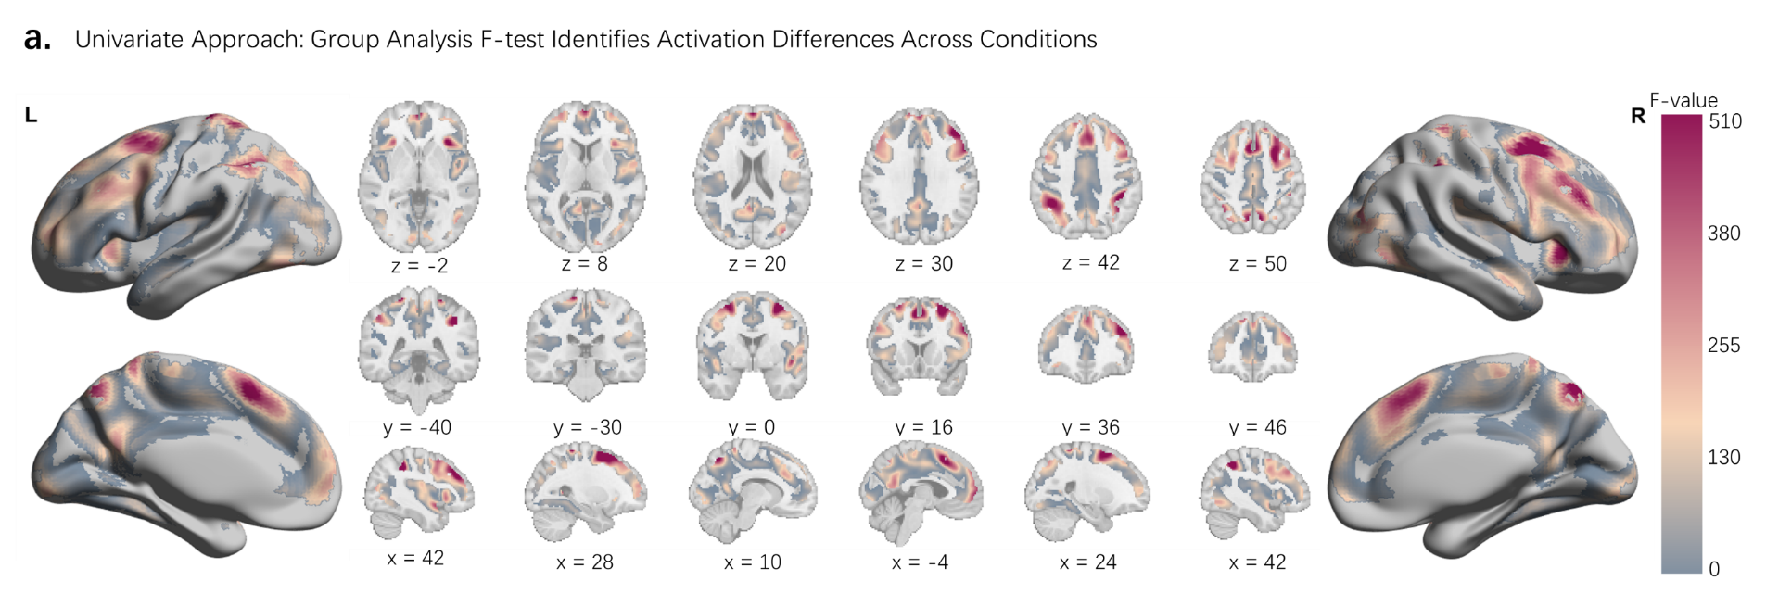

**Supplementary Fig. 3.** Second-level analysis of β parameter estimates for differential working memory load conditions (2-back minus 0-back) across four visual stimulus categories. Results from repeated-measures ANOVA showing voxel-wise significance (FDR-corrected q < 0.0001) with a minimum cluster extent threshold of 40 contiguous voxels.



**Supplementary Fig. 4.** Validation of multivoxel patterns classification in dorsolateral prefrontal cortex (dlPFC) subregions: Brodmann areas (BA) 9 (a) and 46(b).

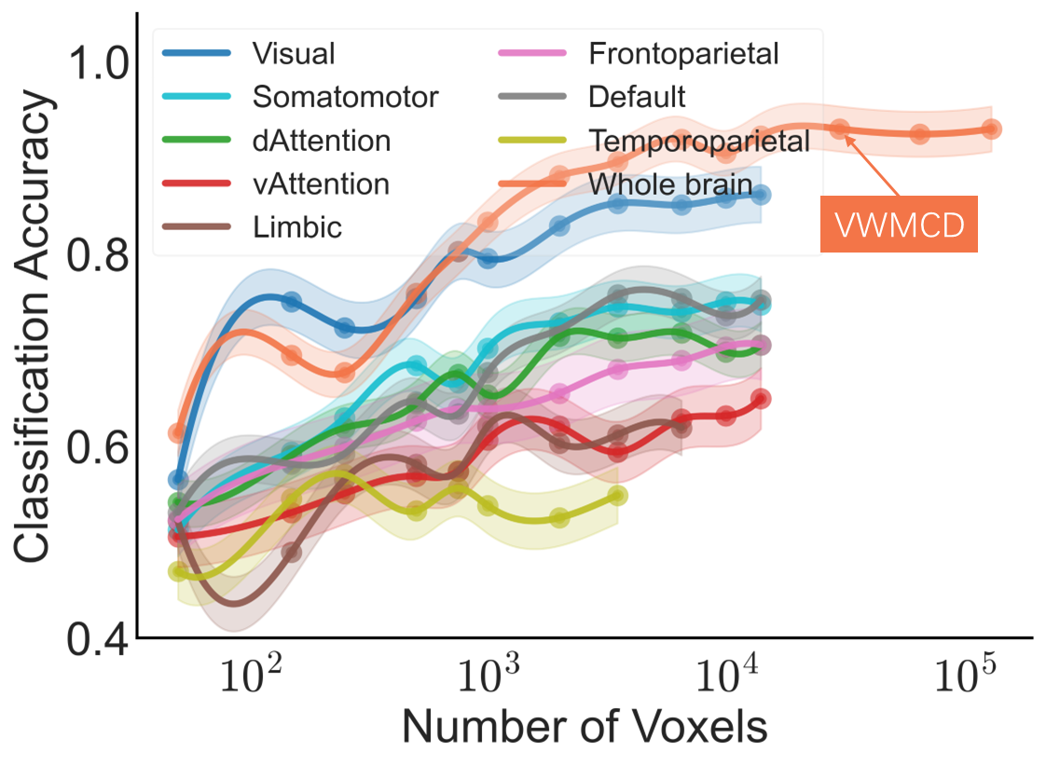

**Supplementary Fig. 5.** Comparative classiﬁcation performance on validation data across eight functional networks (Visual, Somatomotor, Dorsal Attention, Ventral Attention, Limbic, Frontoparietal, Default, Temporoparietal) versus the whole-brain distributed VWMCD. Analyses employed linear SVC with 10-fold cross-validation (100 random iterations per network), controlling for matched voxel counts across subnetworks.

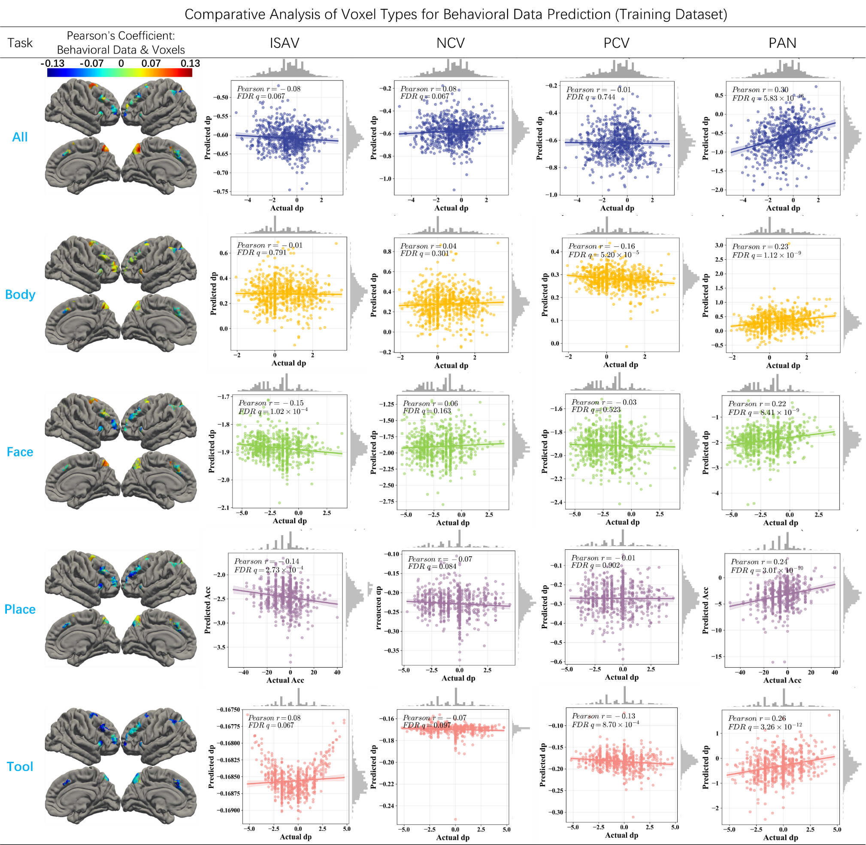

**Supplementary Fig. 6.** Behavioral performance prediction analysis in the training dataset (condition-wise β parameter estimates). Left: Pearson correlation coefficients between voxels and behavioral d' scores. Right: Pearson correlations emerged between predicted and actual d' across five conditions (All, Body, Face, Place, Tool) using condition-specific ISAV, NCV, PCV, and PAN features. Analyses employed Support Vector Regression (SVR) with 100×10-fold cross-validation. Note: ISAV (Initial Set Activation Value), PCV (Positively Correlated Voxels), and NCV (Negatively Correlated Voxels) denote mean activation values within respective voxel subsets.



**Supplementary Fig. 7.** Behavioral performance prediction analysis using condition-wise β parameter in the training dataset. Pearson correlations emerged between predicted and actual d' score across five conditions (All, Body, Face, Place, Tool) using Initial set all voxels (ISAVs features. Analyses employed Support Vector Regression (SVR) with 100×10-fold cross-validation.

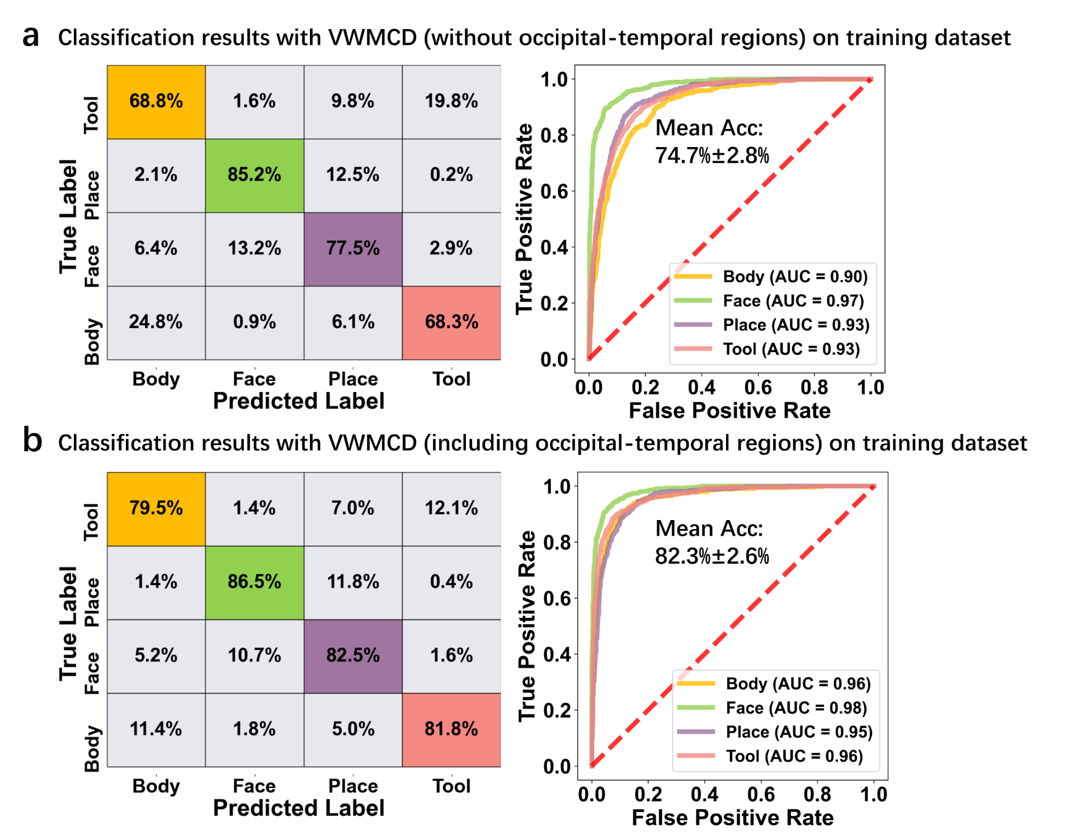

**Supplementary Fig. 8.** Evaluation of occipitotemporal contributions to cross-decoding performance. (a) Classification results following voxel-wise exclusion of visual perception-related occipitotemporal regions (e.g., STG, OcG). Excluded voxels were replaced via bootstrap sampling (100 iteration) from non-visual regions to preserve feature dimensionality. (b) Intact model performance with occipitotemporal regions included. All metrics evaluated through 100$\times$10-fold cross-validation.

**Supplementary Table 1.** Brain regions implicated in visual working memory categories decoder (VWMCD) based on multivariate voxel pattern decoding weights. Lists MNI coordinates and corresponding weights of peak voxels within each cluster, computed automatically using AFNI software. Anatomical labeling follows the Brainnetome Atlas standard.

|  |  |  |  |  |  |
| --- | --- | --- | --- | --- | --- |
| **#Voxels** | **Brainnetcome Region** | **MNIX** | **MNIY** | **MNIZ** | **Weights** |
| 1608 | SFG-R (A10m) | 0 | 60 | 20 | -19.88 |
| 1230 | IPL-R (A40rd) | 48 | -40 | 44 | 28.65 |
| 766 | MFG-R(A6vl) | 30 | 2 | 56 | 26.41 |
| 727 | Pcun-R(A7m) | 8 | -66 | 54 | 27.32 |
| 725 | OcG-R(mOccG) | 38 | -82 | 16 | -22.67 |
| 548 | SFG-L(A8m_L) | -6 | 16 | 48 | 24.31 |
| 481 | IPL-L(A39rd_L) | -44 | -50 | 44 | 23.81 |
| 450 | PoG-R(A1/2/3tru) | 24 | -36 | 70 | -19.58 |
| 438 | MFG-R(A8vl) | 40 | 34 | 30 | 23.54 |
| 348 | IPL-L(A39c) | -32 | -90 | 20 | -19.3 |
| 329 | MFG-L(A6vl) | -26 | 2 | 54 | 22.46 |
| 316 | PrG(A4ul) | -16 | -26 | 74 | -18.19 |
| 308 | INS-R(vld/vlg) | 44 | 4 | -10 | -17.54 |
| 264 | Pcun-L(dmPOS) | -12 | -58 | 14 | -17.66 |
| 214 | PCL-R(A4ll) | 0 | -26 | 60 | -16.48 |
| 210 | STG-L(A38m) | -36 | 14 | -24 | -16.12 |
| 93 | INS-R(dla) | 32 | 24 | -2 | 19.68 |
| 82 | MFG-L(A46) | -32 | 54 | 12 | 18.95 |
| 68 | Pcun-R(dmPOS) | 18 | -56 | 16 | -14.75 |
| 67 | OrG-L(A12/47o) | -36 | 36 | -12 | -15.83 |
| 59 | MFG-L(A8vl) | -44 | 28 | 34 | 18.41 |
| 44 | FuG-L(A37lv) | -42 | -68 | -8 | -13.86 |
| 43 | MTG-R(A21r) | 50 | 16 | -30 | -14.84 |

**Supplementary Table 2.** Conjunction analysis of visual working memory categories decoder (VWMCD) multivariate pattern weights and univariate reconstructed activation patterns. Identifies brain regions exhibiting concordant polarity (positive weights corresponding to activated areas, negative weights to deactivated areas). Lists MNI coordinates and corresponding weights of peak voxels within each cluster, computed automatically using AFNI software. Anatomical labeling follows the Brainnetome Atlas standard.

|  |  |  |  |  |
| --- | --- | --- | --- | --- |
| **#Voxels** | **MNIX** | **MNIY** | **MNIZ** | **Brainnetcome Region** |
| 2324 | -3 | 53 | 10 | SFG-L(A10m) |
| 846 | 38 | 44 | 23 | MFG-R(A9/46v) |
| 628 | 1 | 22 | 46 | SFG-R(A8m) |
| 584 | -3 | -55 | 14 | Pcun-L(A31) |
| 494 | 29 | 11 | 57 | MFG-R(A6vl) |
| 423 | -34 | 54 | 10 | MFG-L(A46) |
| 368 | -44 | 26 | 32 | MFG-L(IFJ) |
| 260 | 2 | -70 | 51 | Pcun-R(A7m) |
| 245 | -26 | 6 | 59 | MFG-L(A6vl) |
| 234 | 42 | -52 | 48 | IPL-R(A39rd) |
| 192 | 36 | 23 | 0 | INS-R(dla) |
| 178 | -34 | 22 | 1 | INS-L(dla) |
| 127 | -39 | 28 | -15 | OrG-L(A12/47o) |
| 121 | -38 | -52 | 46 | SPL-L(A5l) |
| 58 | 0 | -10 | 49 | SFG-L(A6m) |
| 40 | 52 | 0 | 2 | STG-R(TE1.0_TE1.2) |

**Supplementary Table 3.** Whole-brain classification performance using **top m%** weight-ranked voxels from the visual working memory category decoder (VWMCD) (Training dataset: n=561)

|  |  |  |
| --- | --- | --- |
| **Top m% Voxels** | **Accuracy (Mean ± SD)** | **AUC (Mean ± SD)** |
| 1 | 0.565 ± 0.042 | 0.826 ± 0.061 |
| 2 | 0.586 ± 0.032 | 0.838 ± 0.058 |
| 3 | 0.595 ± 0.048 | 0.848 ± 0.054 |
| 4 | 0.611 ± 0.041 | 0.857 ± 0.053 |
| 5 | 0.632 ± 0.048 | 0.865 ± 0.054 |
| **10** | **0.673 ± 0.042** | **0.890 ± 0.047** |
| 20 | 0.798 ± 0.025 | 0.947 ± 0.015 |
| 30 | 0.851 ± 0.027 | 0.967 ± 0.007 |
| 40 | 0.867 ± 0.024 | 0.972 ± 0.006 |
| 50 | 0.869 ± 0.023 | 0.974 ± 0.006 |
| 60 | 0.878 ± 0.021 | 0.978 ± 0.006 |
| 70 | 0.893 ± 0.023 | 0.980 ± 0.006 |
| 80 | 0.899 ± 0.021 | 0.982 ± 0.006 |
| 90 | 0.909 ± 0.021 | 0.985 ± 0.005 |
| 50 | 0.911 ± 0.021 | 0.987 ± 0.005 |

**Supplementary Table 4.** Whole-brain classification performance using **top and bottom** m% weight-ranked voxels from the visual working memory category decoder (VWMCD) (Training dataset: n=561)

|  |  |  |
| --- | --- | --- |
| **Top & Bottom m% Voxels** | **Accuracy (Mean ± SD)** | **AUC (Mean ± SD)** |
| 1 | 0.647 ± 0.025 | 0.881 ± 0.044 |
| 2 | 0.713 ± 0.025 | 0.911 ± 0.036 |
| 3 | 0.743 ± 0.018 | 0.926 ± 0.029 |
| 4 | 0.790 ± 0.025 | 0.946 ± 0.019 |
| **5** | **0.823 ± 0.026** | **0.964 ± 0.011** |
| 6 | 0.825 ± 0.015 | 0.959 ± 0.014 |
| 7 | 0.835 ± 0.017 | 0.963 ± 0.013 |
| 8 | 0.844 ± 0.015 | 0.965 ± 0.012 |
| 9 | 0.848 ± 0.010 | 0.967 ± 0.011 |
| 10 | 0.852 ± 0.010 | 0.969 ± 0.010 |
| 20 | 0.888 ± 0.011 | 0.981 ± 0.006 |
| 30 | 0.908 ± 0.021 | 0.985 ± 0.005 |
| 40 | 0.912 ± 0.018 | 0.986 ± 0.005 |
| 50 | 0.911 ± 0.021 | 0.987 ± 0.005 |